# Program Design

Figure 1 details the decision flows that dictate which consumer demographic aligns with one of three specific bundled products which includes the intervention, incentivization program, policy type and face value. Depending on the characteristics of the policyholder, such as age and smoking status, they may be eligible for one of the three bundles. The subsequent section outlines each program, their incentives for participation, key features and evaluation timelines.

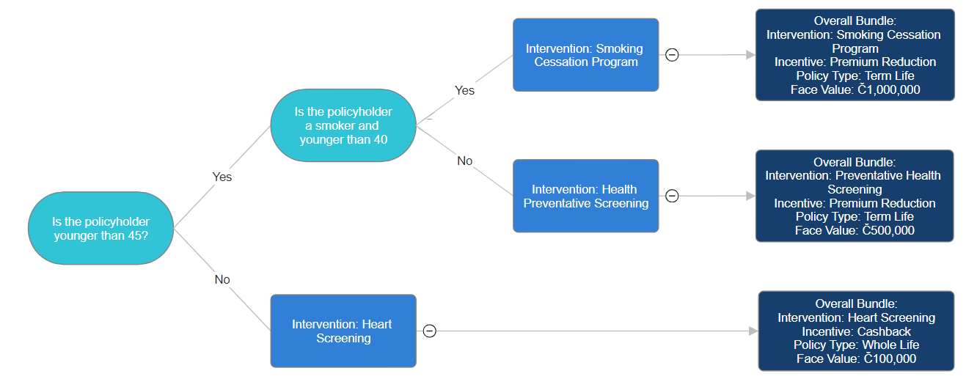

*Figure 1: SuperLife’s Health Program Bundles*

### 20 Year Term Life Insurance with Smoking Cessation Program

This product bundle will be issued to smokers 40 years old or younger with a smoking cessation program and a 20-year term life insurance product of Č1m sum insured. The smoking cessation program will provide participants with resources, including support groups. The program’s average mortality can be reduced by 46.26% given the smoker quits (see Appendix A1).

LCG has identified smokers as a key underrepresented demographic, given smokers comprise only 6.3% of SuperLife’s policies compared to 18% of Lumaria’s population, with this number falling to just 3.8% for policies written in the last five years, as seen in Figure 2. This presents an opportunity to greatly improve health outcomes, reduce mortality and add economic value. For this reason, smokers under the age of 40 who purchase a policy with a sum insured of Č1m, will be eligible to participate in a smoking cessation program. Due to the observed increase in mortality for smokers after age 40 within our in-force data, as well as, empirical evidence demonstrating that smoking cessation at ages below 40 have a mortality reduction of up to 90% of the excess risk from smoking (Thomson et al. 2022)11 and smokers aged below 40 have higher attempt and success rates of quitting (Kim. Y, Lee. J & Cho. W, 2021)5 participants must be aged under 40 to be eligible. However, due to the high upfront costs associated with the program (see Appendix A2), a face value of Č1m is required to be eligible for the program.

|  |  |  |
| --- | --- | --- |
| Data | Non-smoker | Smoker |
| SuperLife In-force Policyholders | 93.7% | 6.3% |
| SuperLife In-force Policyholders for Policies Written in Last Five Years | 96.2% | 3.8% |
| Lumarian Population | 82% | 18% |

*Figure 2: Proportion Of Smokers For SuperLife’s In-force Policies And The General Population*

To incentivize program participation, LCG recommends introducing premium reductions to policyholders who participate in the program, whereby policyholders under the age of 30 will be given a 2% discount, policyholders between the ages of 30-34 a 5% discount, and policyholders between the ages of 35-40 an 8% discount. These premium discounts are targeted incentives that encourage policyholders to engage with healthy behaviours that otherwise would not be recognized in pricing decisions. LCG recommends premium reductions over alternate incentives due to ease of implementation, low operational costs, clear and direct relationship in encouraging program participation and high confidence in projecting economic value added. The size of the eligible discount increasing with age has been decided according to our goal of increasing the sales and competitiveness of SuperLife’s life insurance offerings, given the higher profitability at ages 30-40 had these stepped reductions not been implemented (see Appendix B), as well as, our expectation of Lumaria’s population to age (see Appendix C4).

### 20 Year Term Life Insurance with General Health Screening Program

Our proposed T20 life insurance offering for non-smokers under 45 includes the general health screening intervention with a sum insured of Č500,000. This non-specific health intervention acts as a preventative measure to reduce mortality of otherwise healthy individuals. As with our other T20 life program, reduced premiums will act as an incentive to encourage participation with the condition of engaging with the preventative screening every two years.

With a program catered to young smokers established, another program catered for young non-smokers would diversify the target markets. External research into incentives for preventative screening found estimates of 23% reductions in mortality rates, demonstrating a reduction greater than the 5-10% range provided in our intervention data, and resulting in our conservative expected mortality reduction of 8% (McCracken et al., 2024)10. Due to the upfront costs of this measure, policyholders will be required to have a face value of Č500,000 to be eligible.

Similar to our T20 Smoker offering, policyholders who engage with this program will be eligible for premium reductions. Those aged 30 or under are eligible for a 3% premium reduction, and those aged between 31-45, 5%. This rewards healthy behaviours that would otherwise not be priced into life insurance products, with the size of this reduction being consistent with the profitability and competitiveness of the product.

### Whole Life Insurance with Heart Health Screening

Our proposed WL insurance offering would be aimed at non-smokers older than 45 through a heart screening program with a sum insured of Č100,000. The program consists of regular screenings for cholesterol levels and blood pressure, with cash-backs incentives conditional on program engagement every two years.

In-force policy data shows 31.30% of deaths amongst policyholders occurring due to heart-related issues (see Figure 3), with these deaths being more common among WL policyholders (see Appendix A3). Moreover, research found that heart-screening initiatives were especially recommended for those over 45. (Department of Health and Aged Care, 2023)8. Further external research found an 11% reduction in all-cause mortality from just cardiovascular screenings (Lindholt et al., 2023)7. Hence, LCG adopted a conservative expected mortality reduction of 8%.

As the upfront costs of this offering are not as high as the T20 offerings, this product will be available to those with a sum insured of Č100,000 to target lower socioeconomic individuals with a lower upfront premium for WL insurance. Policyholders who participate with the program will be awarded a

cash-back of 2% of the initial lump sum premium upon death. This is to incentivize healthy preventative measures that induce mortality reductions.

*Figure 3: Cause of Death Among In-force Policyholders*

### Other Program Features

In addition to the program features designed to encourage policyholders to participate in programs that induce mortality reduction, LCG has proposed a range of measures to ensure the competitiveness and marketability of these life insurance offerings.

*Entitled Issue Ages:* We recommend a restriction on entitled issue ages to individuals aged 26 to 65. This assumption was established from SuperLife’s in-force data only pertaining to issue ages ranging from 26 to 65. Furthermore, programs would be less effective at reducing mortality and risk not being profitable outside of these ranges.

*Distribution Channels:* The popular distribution channels for each policy type is an essential consideration in maximizing product competitiveness and marketability. Appendix A4 shows the distribution channel for each insurance product expected as percentage of sales. We recommend an increase in online marketing for all three products, particularly T20 products, due to the increase in online sales in the last five years to 49.8% of all policies (see Appendix A4). Additionally, we recommend that SuperLife trains agents to convey the benefits of their WL insurance offerings, as it continues to be the most popular distribution channel for WL.

### Evaluation of the Program

Our short-term and long-term timeframes for evaluating the program have been formulated based on SuperLife’s primary goals, as well as any potential risks and ethical considerations.

Our short-term timeframe aims to address the primary goals of encouraging healthy behaviours, boosting life insurance sales and improving product competitiveness, as well as key risks that we have identified (see Figure 8), whereas the long-term timeframe aims to address SuperLife’s goals of reducing mortality and adding economic value, and reassesses the key risks that we have identified. A five-year horizon was chosen to have enough data and experience to draw accurate conclusions without the risk of investing heavily into a program that doesn’t align with our objectives.

The short-term time frame ensures that the program which achieves SuperLife’s objectives of incentivizing healthy behaviours, is a differentiated life insurance offering within the Lumarian life insurance market that is marketed well and is profitable and financially feasible for the remainder of the program. Additionally, the key risks and ethical issues that LCG have identified for this program will be assessed, and corresponding risk mitigation measures will be implemented if necessary. As this is a key time to ensure successful implementation of the proposed life insurance offerings, monthly monitoring of new business and in-force claims will be done, with appropriate pricing adjustments made if necessary. Additionally, to ensure that SuperLife administers these interventions and incentives in a transparent manner, quarterly policyholder surveys will be conducted, as well as a platform where policyholders can share their feedback at any point in time.

Beyond this short-term horizon, the objectives of reducing mortality and adding economic value to SuperLife will also be assessed. Added economic value determined by our pricing models over 20-year, 40-year and 60-year time horizons will be monitored on an annual basis, with premium adjustments (i.e. revision of premium reductions and cash-backs) made if necessary. To ensure the continued success and sustainability of the proposed life insurance offerings, quarterly monitoring of new business and in-force claims will be done, with appropriate pricing adjustments made if necessary. Furthermore, risks and ethical considerations will be regularly reviewed and corresponding mitigation strategies will be actioned where appropriate. To ensure that SuperLife continues to remain ethical in their operations, the quarterly policyholder surveys and feedback platforms will continue to be maintained and monitored.